13 Setting Up Grains

1. Create Geometry Node, enter and Create File Node,

set Geometry File = Horned_Sea_Star_reduced.obj;

1. Create Vellum Configure Grain Node, set Create Points from Volume on, Particle Size = 0.02, Jitter Scale On,

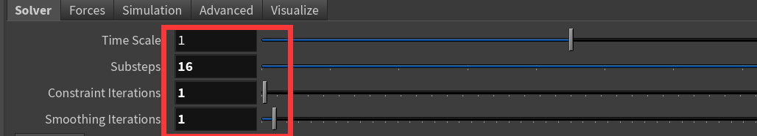

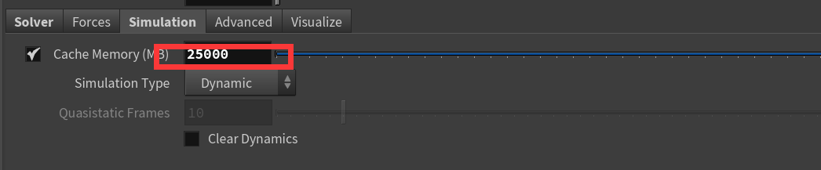

Go to Frame 100, bake, play;

1. Create TimeShift Node, set Frame = 72;
2. Create UV Texture Node, set Attribute Class = Point, Scale Y = 0.8;
3. Create Attribute From Map Node

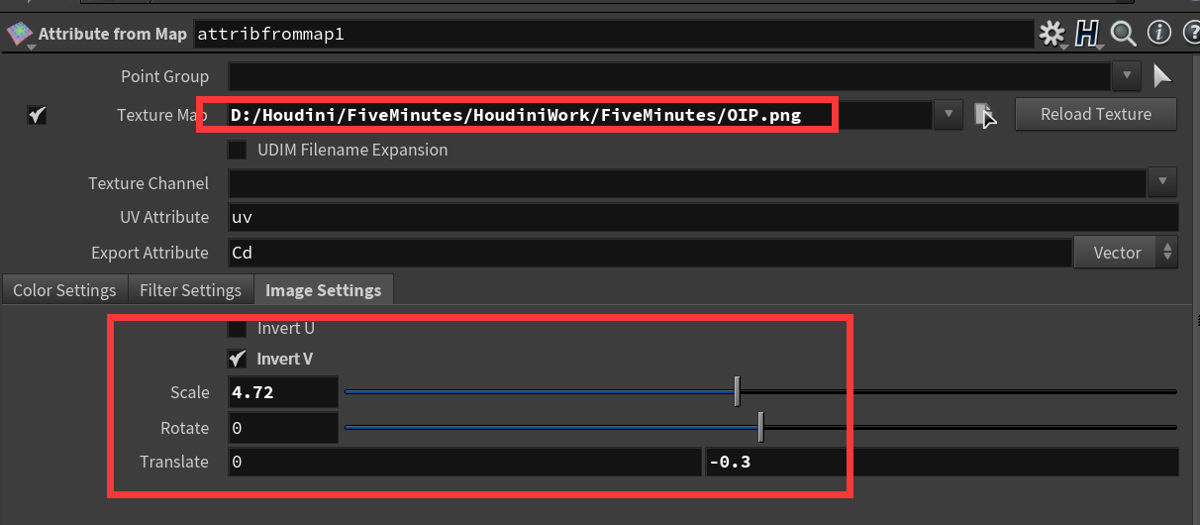

1. Create Attribute VOP Node after vellumsolver1 and uvtexture1;

